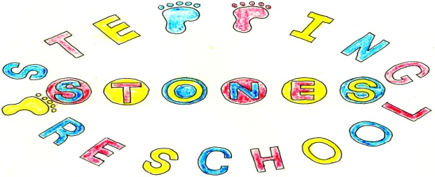

Stepping Stones Pre-School
Special Educational Needs and Disabilities Policy
Our Pre-School has regards to the Special Educational Needs and Disability (SEND) Code of Practice on the identification and Assessment of Special Educational Needs, the Equality Act 2010 and provides welcome and appropriate learning opportunities for all children. We will not directly or indirectly discriminate, harass or victimise anyone who attends the setting
The SEND Code of Practice is used within the group to support children using Individual Plans (IP’s) with support from outside agencies under the guidance of our Special Educational Needs Coordinator.
Children with additional needs, like all other children, are admitted to the Pre-School after consultation between parents, Pre-School manager and other relevant organisations.
Our system of observation and record keeping which operates in conjunction with parents and other professional agencies enables us to monitor children’s needs and progress on an individual basis and ensure our setting has an effective inclusive practice.
If it is felt that a child’s needs cannot be met in the Pre-School without additional adult support, funding will be sought to provide it. Parents are expected to agree for the application for additional funding to meet the needs of their child if asked.
We work in liaison with professionals outside the Group, including therapists, health visitors, educational psychologists, social workers, paediatricians and our Best Start in Life Advisor, to meet children’s specific needs and support our work with Individual Education Plans. To meet the needs of the child you are expected to agree to us seeking outside professional help.
Our staff attend, wherever possible, training to support any additional needs.

Special Educational Needs Coordinator for the Group is Donna Peters, Manager

THIS POLICY WAS ADOPTED AT A MEETING OF THE
PRE-SCHOOL HELD ON (DATE)...........................................................
SIGNED ON BEHALF OF THE PRE-SCHOOL......................................

Reviewed January 2011 vc

