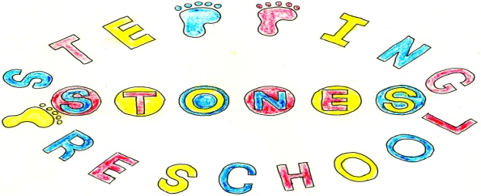

Stepping Stones Pre School
Social Networking Policy

Social networking sites are now commonly used as a communications channel, both for personal and business purposes. They provide the facility for people to interact socially (e.g. posting comments, instant messaging, emailing, sharing media like photos and film). They also provide a fast, modern way for organisations to communicate and engage with others. This Policy sets out guidelines about the use of social networking sites, for business and for personal use.

Scope

For the purposes of this policy, social networking is defined as the use of any website where information can be shared publicly with others on sites such Facebook, X, YouTube and LinkedIn. This policy applies irrespective of how the social networking site is accessed and includes anything posted which may be viewed by others and may including instant messaging, blogging, photographs, video footage amongst others.

Social Network Use

- The reputation of the Pre School, its committee, parents, children or employees must not be brought into disrepute through the use of social networking sites.
- Confidentiality must be maintained at all times so that the group is not exposed to legal risks including data protection, libel and Freedom of Information legislation.
- Use of social networking sites must ensure the safeguarding of children in accordance with the Safeguarding Vulnerable Groups Act 2006.
- Sites must not be used for purposes which constitute bullying or harassment or for uploading information which may be discriminatory or offensive nature.
- The occupation and employee of practitioners should not be divulged on social networking sites including the pre school address, logo, e mail address or photographs taken while in the group.

We acknowledge that practitioners will want to monitor their child’s contacts on social networking sites but recommend the following procedures to protect themselves and the setting.

Guidelines for using technology to communicate with children and young people.
- Adults should not give out their personal contact details, including mobile telephone number and details of blogs or personal web sites.
- Only use equipment for example mobile phones, provided by an organisation to communicate with children, making sure parents have given permission for this form of communication to be used
- Only make contact with children for professional reasons and in accordance with the organisations policy
- Recognise that text messaging is rarely an appropriate response to a child in a crisis situation or at risk from harm. It should only be used as a last resort when other forms of communications are not possible
- Not use internet or web based communication channels to send personal messages to a child / young person
- Ensure that if a social networking site is used, details are not shared with children and young people and privacy settings are set at maximum
These guidelines aim to raise awareness of social network users of the need protect themselves from:-allegations of abuse against children
- ensure that the confidentiality policy is adhered to
- protect practitioners from identity fraud
- keep the setting its parents, children and practitioners safe from online access

See also the policy on Safeguarding and Promoting Children’s Welfare, ICT and Whistle Blowing.

THIS POLICY WAS ADOPTED AT A MEETING OF THE
PRE SCHOOL HELD ON (DATE)..........................................................

SIGNED ON BEHALF OF THE PRE SCHOOL..........................................

