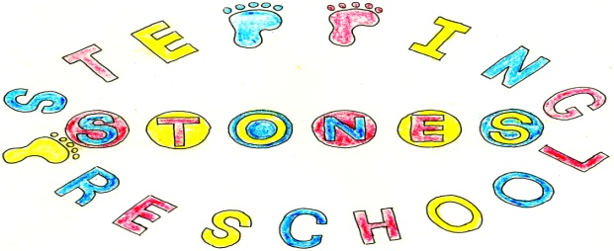

Stepping Stones Pre School
Physical Activity Safety Policy

All equipment will be checked for safety before each session and positioned away from other equipment or obstructions. All unsafe equipment will be removed for mending or thrown away to prevent accidents.

Inside Play

Risk assessments will be carried out to mitigate risks involved with day to day activities at pre school.

Children will be taught to use and carry scissors safely and will be supervised when using them.
Knives will be closely supervised during cookery sessions and kept out of the reach of children when not being used.
Children will be discouraged from putting small objects in their mouth.
Children will be taught the rules of the group to develop their own risk awareness.
Walking is encouraged in the playroom and toilet area.
Children will be taught the rules of the group to develop their understanding of risk.

Outside Play
A risk assessment will be carried out daily to ensure safety before use.
Children will help to do the risk assessment to develop their own risk awareness.
Wooden equipment will not be used when wet and slippery and this will be explained to the children.
Children will be made aware of the safe way to play with sand. The sand pit will be covered when not in use.
The slide frame and fireman’s pole will be supervised by an adult at all times.
Children will not play under the slide section of the frame.
When using the slide children will not climb up it. Children will have their clothing secured and laces tied to ensure safe movement.
Suitable footwear and clothing will be encouraged to allow ease of movement.
We will encourage children to come to preschool with sunscreen, hats and suitable clothing to protect their skin in the sunny months.
During bad or cold weather we will encourage children to have coats and clothing that will allow them to explore our outside area in all weather types.

THIS POLICY WAS ADOPTED AT A MEETING OF THE
PRE SCHOOL HELD ON (DATE)...............................................................................

SIGNED ON BEHALF OF THE PRE SCHOOL..............................................................

