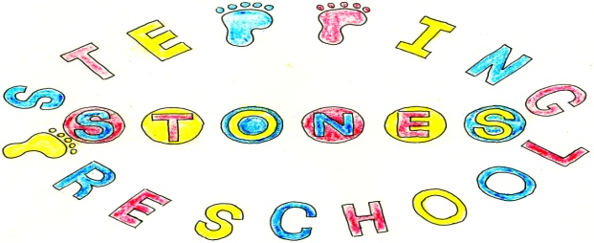
Stepping Stones Pre School
Oral Health Policy

The setting provides care for children and promotes health through promoting oral health and hygiene, encouraging healthy eating, healthy snacks and tooth brushing.
Oral health
- Fresh drinking water is always available and easily accessible.
- Sugary drinks are not served.
- In partnership with parents/carers, children are introduced to an open free-flowing cup when appropriate.
- Only water and milk are served with morning and afternoon snacks.
- Children are offered healthy nutritious snacks with no added sugar.
- Parents/carers are encouraged to provide a healthy balanced lunch box.
Where children clean their teeth when at the setting
- Children are encouraged to brush their teeth as part of the daily routine. Teeth should not be cleaned for at least one hour after a meal as this can cause loss of enamel.
- Each child has their own toothbrush, which is stored individually to prevent accidental contact and cross contamination.
- A small amount of toothpaste is put onto a blue paper towel before applying to the brush to prevent cross contamination.
- Toothbrushes are cleaned at each session and sterilised weekly in Milton or similar disinfecting fluid.
- Toothbrushes are changed every three months
- Oral hygiene activities are included in planning at least every three months when toothbrushes are changed.
- The setting co-ordinates with local oral health and ensure procedures are reviewed regularly, additional guidance from the local team may be added to this procedure.

Pacifiers/dummies
- Parents/carers are advised to stop using dummies/pacifiers.
- Dummies that are damaged are disposed of and parents/carers are told that this has happened

THIS POLICY WAS ADOPTED AT A MEETING OF
THE PRESCHOOL HELD ON (DATE) ....................................................

SIGNED ON BEHALF OF THE PRESCHOOL...........................................

