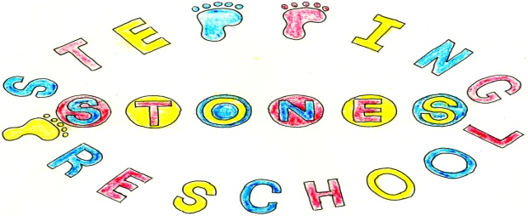
Stepping Stones Pre School
Mobile Phone Policy
Mobile phones are becoming increasingly more sophisticated allowing access to new content and services such as the internet, social networking sites and instant messaging. Many offer camera, video and audio recording as standard. They offer high speed methods of communication but they are also associated with risks. Acceptable use and management of mobile phones is applied through the Mobile Phone Policy. Personal use of mobile phones is controlled and not allowed in the personal care area but it is recognised that banning their use in the setting is unrealistic.
This Policy aims to protect children from harm, by ensuring the safe management and use of mobile phone by all individuals who come into the setting. Alongside the potential risks, mobile phones are an effective communication tool which contributes to safeguarding practice and protection. This policy applies to all individuals who have access to and/or work related mobile phones within the setting environment. This will include children and young people, parents and carers, practitioners and their managers, volunteers, students, committee members, visitors, contractors and community users.
Mobile phones may give cause for concern by misuse including the taking and distribution of indecent images, exploitation and bullying, such misuse will have a negative impact on an individual’s safety, dignity, privacy and right to confidentiality. The needs and vulnerabilities of all must be respected and protected. Mobile phones may also cause an unnecessary distraction during the working day and are often considered intrusive when using in the company of others. It may be difficult to detect the use or misuse of mobile phones.
The vulnerable areas in the setting are the hall, toilet areas and changing rooms and there are signs displayed to show that these are areas free from mobile phone and other ICT equipment with the capability of recording visual images.
Practitioners and their manager will
- Be aware of the need to protect children from harm.
- Have a clear understanding of what constitutes misuse.
- Know how to minimise risk.
- Be vigilant and alert to potential warning signs of misuse.
- Avoid putting themselves into compromising situations which could be misinterpreted and lead to potential allegations
- Understand the need for professional boundaries and clear guidance regarding acceptable use
- Be responsible for the self moderation of their own behaviours
- Be aware of the importance of reporting concerns immediately

Practitioners may leave their mobile phones turned on during sessions but they should be stored in the mobile phone box in the kitchen where they are visible at all times. Phone can also be stored safely in the cupboard in practitioner’s bags.

The recording, taking and sharing of images on mobile phones should not be done using practitioners personal equipment but is restricted to the settings camera, video and ICT equipment.

The only mobile phone to be used in the setting is the designated pre-school phone. Only the settings mobile phone will be used to phone parents or send text messages unless an emergency situation occurs.

Practitioners who wish to use their phone in the setting should first gain permission from the Designated Safeguarding Officer or deputy and use their phone in an area visible to all. No liability for loss and/or damage can be accepted
Parents who wish to film their child at special events are expected to support the setting in keeping children safe by considering the wishes of all parents. Some children will not be permitted to have their photo taken and so permission from the Designated Safeguarding Officer or Deputy must be obtained prior to taking photos. Generally in group situations parents are not permitted to take group photos but individual photos at the end of any given situation.

If the manager or anyone within the setting has reported a concern regarding phone use and content the Whistle Blowing policy and procedure will be followed. If the concern is regarding parents or carers the Safeguarding policy and procedure will be followed.

Images and video should be for their own family’s personal use only. If images are shared online, access should be limited to immediate family only and not made public. Families are NOT permitted to share photos of children on any platform that are not in their family.

The setting may use their mobile phone to text, email and make and receive calls. It is an essential part of the emergency toolkit which is taken on trips and outings. It allows contact outside of the settings opening hours.

Only authorised individuals will have access to the work mobile which will be stored safely if not in use.

Personal calls should not be make on the work mobile phone, other than in agreed circumstances.

THIS POLICY WAS ADOPTED AT A MEETING OF
THE PRESCHOOL HELD ON (DATE) ....................................................

SIGNED ON BEHALF OF THE PRESCHOOL...........................................

