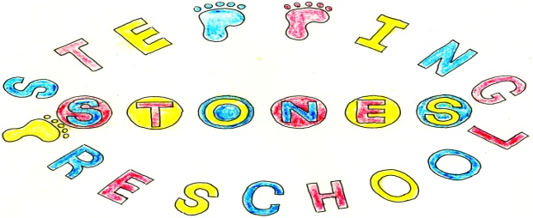

Stepping Stones Pre School
Contingency Policy

Redundancy
If an employee becomes redundant the following redundancy payments must be made:

For employees over the age of 41 – one and a half weeks’ salary for each full year of service.

For employees between the ages of 22 and 41 – one weeks’ salary for each full year of service.

For employees between the ages of 16 and 21 – half a weeks’ salary for each full year of service.

The salary is dependent on the pay scale valid at the time the member or members were declared redundant but is capped at £719.00 per week. The maximum amount of statutory redundancy pay is £21,570.00.
Length of service is capped at 20 years.
If you were made redundant on or after 6 April 2019, your weekly pay is capped at £525 and the maximum statutory redundancy pay you can get is £15,750. If you were made redundant before 6 April 2019, these amounts will be lower.
Exceptions
You’re not entitled to statutory redundancy pay if:
- your employer offers to keep you on
- your employer offers you suitable alternative work which you refuse without good reason
Being dismissed for misconduct does not count as redundancy, so you would not get redundancy pay if this happened.
Apprentices are eligible for statutory redundancy pay if they have been employed for at least two years continuously with the same employer.
Redundancy pay, including any severance pay under £30,000 is not taxable.
Your employer will deduct tax and National Insurance contributions from any wages or holiday pay they owe you.
The committee will endeavour to ensure relevant funds to cover this are held in an account.

Premises

In the event of closure of Pre school due to circumstances beyond our control staff wages will be paid for the day(s) and the committee will seek reimbursement of rent paid for the missed day(s).

In the event of closure of Pre school due to events beyond our control such as having to respond to Government guidelines, staff will be paid the first two weeks wages. An emergency committee meeting will be held within these two weeks to decide upon the next course of action.

Staff will be informed of the date, time and place of the meeting and will be informed of any decision made.

Short-term and temporary lay-offs
You can claim statutory redundancy pay if you’re eligible and you’ve been temporarily laid off (without pay or less than half a week’s pay) for either:
- more than 4 weeks in a row
- more than 6 non-consecutive weeks in a 13 week period
Write to your employer telling them you intend to claim statutory redundancy pay. This must be done within 4 weeks of your last non-working day in the 4 or 6 week period.
If your employer does not reject your claim within 7 days of receiving it, write to your employer again giving them your notice.
Your claim could be rejected if your normal work is likely to start within 4 weeks and continue for at least 13 weeks.

It is hoped that staff will continue to be paid as long as the Government funding for 2 year olds, 3/4 year old and 30 hour funding continues to be paid during a pandemic/emergency/other disaster for shutdowns/isolations and other disaster/emergency situations at the manager and chair persons discretion. This will have to be kept under review to make sure that there are sufficient funds to allow this. If funds are running low another emergency meeting will be called to make a plan and to move forwards.

THIS POLICY WAS ADOPTED AT A MEETING OF THE
PRE SCHOOL HELD ON (DATE)...........................................................

SIGNED ON BEHALF OF THE PRE SCHOOL..........................................

