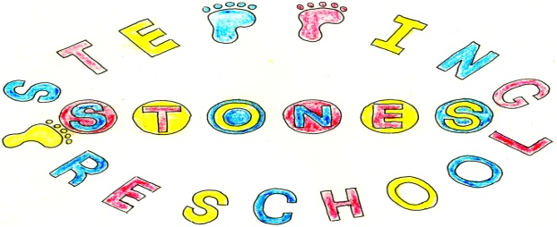

Stepping Stones Pre school
Confidentiality Policy

The Pre school’s work with children and families will sometimes bring us into contact with confidential information.

To ensure that all those using and working in the Pre school can do so with confidence, we will respect confidentiality in the following way:-

Parents will have ready access to the files and records of their own children but will not have access to information about any other child.

Staff will not discuss individual children outside of the setting.

In your admission pack you sign to give permission for us to discuss your child with other professionals involved in supporting your child.

Any information relating to a child’s safeguarding will be kept in a confidential file and will not be shared with the Group and will only be seen by the Designated Safeguarding Lead or the Deputy or Assistant Deputy. Unless it is in the best interest of the child to do so.

All children’s records and information will be kept securely locked in a filing cabinet or a password protected lap top.

Children’s records will be destroyed by shredding as soon as possible when no longer required unless we are legally required to keep them for a set period of time.

First aid records will be kept and shredded after 20 years.

All computer records will be password protected and deleted as soon possible when no longer required.

Students in the Pre school will be advised of our Confidentiality Policy and required to adhere to it.

All staff information will remain confidential.

All the undertakings above are subject to the paramount commitment of the Pre school which is to the safety and well-being of the child.

Please also see our General Data Protection Policy

THIS POLICY WAS ADOPTED AT A MEETING OF THE
PRE SCHOOL HELD ON (DATE)..........................................................

SIGNED ON BEHALF OF THE PRE SCHOOL..........................................

