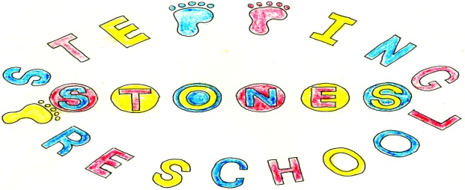
Stepping Stones Pre School
Acceptable Use of Information and Communication Technology (ICT) Policy
The aim of this policy is to safeguard children by promoting appropriate and acceptable use of information and communication technology (ICT). This policy will apply to all individuals who access or are users of work related ICT systems. It ensures that all ICT users are aware of risk, what constitutes misuse and the sanctions that will be applied.
This policy applies to all individuals who have access to ICT systems including children, young people, parents and carers, early years practitioners and their managers, volunteers, students, committee members, visitors, contractors and community users.
Parent and carers, and where applicable, other agencies, will be informed of any incidents of inappropriate use of ICT that take place on-site, and, where relevant, off-site visits.
The persons responsible for ensuring that online safety is an integral part of everyday safeguarding practice are Donna Peters, Hayley Frear and Sarah Selby.
Policies and procedures will be applied to the use of personal ICT equipment by all individuals who come into contact with the early years setting. This will include the personal use of work related resources.
Allegations of misuse or known incidents will be dealt with appropriately and promptly in line with our Whistle blowing policy and procedure.
Effective online safeguarding support systems will be put in place such as filtering controls, secure network and virus protection.
The designated Safeguarding Officer is responsible for ensuring that all policies and procedures are implemented in practice and all updates, issues and concerns are relayed to all ICT users.
The importance of online safety to safeguarding is understood by all ICT users.
The training, learning and development requirements of practitioners will be monitored and additional training needs will be identified and provided for.
A safe ICT learning environment will be promoted and maintained.
Practitioners must report concerns in relation to alleged misuse of known incidents subject to the agreed procedure.
ICT equipment will be checked before use to ensure that all relevant security systems are operational.
Awareness will be raised of any new or potential issues or risks that could be encountered.
Children will be supported and protected whilst using ICT to enable them to use it in a safe and responsive manner. Online safety information will be presented to children in a way that is appropriate for their age and stage of development.
We will encourage children to become active, independent and responsible learners.
Parent and carers will be encourage to sign acceptable use agreements and to share responsibility for their actions and behaviours. This will be instigated when children are enrolled at the setting.
Parents who wish to use personal technologies (such as cameras or phones) within the setting must do so in line with our Camera and Image Policy and Mobile Phone Policy. No image recording devices should be on open view in the setting and are never allowed in the toilet area.
Practitioners may use online technologies to access age appropriate resources for children, for research or for their studies.
All early years practitioners, their managers and volunteers will be subjected to authorised use as agreed by the Designated Person for Safeguarding who is Donna Peters, the deputy Safeguarding Officer is Hayley Frear and the Assistant Deputy Safeguarding Officer is Sarah Selby.
All Early years practitioners will be provided with a copy of the acceptable use policy and a copy of the acceptable use agreement, which must be signed, dated and returned. A copy of this will be kept in the safeguarding file.
Authorised users should have their own individual password to access a filtered internet service provider which should not be disclosed to others. All computers will be locked when unattended to prevent unauthorised access.
The use of personal technologies is subject to the authorisation of the Designated Safeguarding Officer, and such use should be open to scrutiny, monitoring and review.
In the event of misuse, abuse or unlawful activity by early years practitioners, the manager, committee, parents or carers or volunteers -
A report should be made to the Designated Safeguarding Officer unless it is regarding them in which case you can go to the deputy, chairperson or direct to Ofsted. The procedure to be followed should be the Whistle Blowing Policy and procedure or if regarding a parent or carer the safeguarding policy and procedure should be followed.
Children who misuse ICT will be removed from the activity and their parents informed and a record of concern raised if applicable. If a child accidentally accesses inappropriate material it will be reported to the Designated Safeguarding Officer immediately. The computer should not be switched off, nor the page closed, in order to allow investigations to take place.
This policy links with the Safeguarding Policy, ICT Misuse Policy and Whistle Blowing policy which will be referred to when dealing with any incidents that occur as a result of the intentional or unintentional misuse of ICT. Any allegations of abuse or other unlawful activity should be reported immediately to the Designated Safeguarding Officer who will ensure procedures outlined in the above named policies are followed with immediate effect.
This policy also links to the Internet Policy, Camera and Image Policy and the Mobile phone Policy and the Behaviour Policy.
It should be recognised that all inappropriate behaviours will be taken seriously and dealt with in a similar way, whether committed on or offline.
This policy will be monitored and reviewed regularly in an open and transparent way and shared with the relevant individuals at the earliest opportunity.

THIS POLICY WAS ADOPTED AT A MEETING OF
THE PRESCHOOL HELD ON (DATE) ....................................................

SIGNED ON BEHALF OF THE PRESCHOOL...........................................

