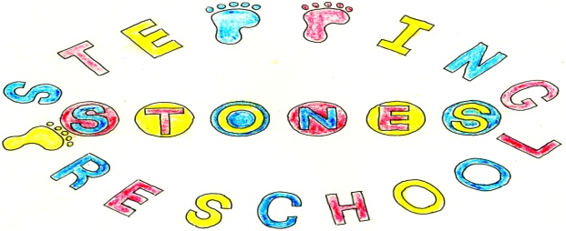

Stepping Stones Pre School
Promoting Positive Behaviour Policy

We believe that children and adults flourish with a consistent routine in which everyone knows what is expected of them and when. We aim to work towards a situation in which children can regulate their own emotions and develop their self-esteem in an atmosphere of mutual respect and encouragement. In order to achieve this:-

Rules governing the conduct of the Group and the behaviour of the children will be discussed and agreed within the Pre School.

We will validate their emotions and feelings during behaviours of distress and work with them to co-regulate their emotions until such times as they can regulate their own emotions.

We create the setting rules with the children such as “we don’t hurt each other” to promote acceptable behaviour and developing social skills.

A visual time line will be used to develop children’s understanding of the routine of the setting.

All adults in the Pre School will ensure that the rules are applied consistently, so that the children understand what is expected of them and can develop their agency and autonomy in a secure environment.

All adults will provide a positive role model for the children with regard to friendliness, care and courtesy.

Adults in the Pre School will praise and endorse appropriate behaviour such as kindness and willingness to share. Sharing will be supported by using a sand timer to ensure children learn to take turns fairly.

We will take positive steps to avoid a situation in which children receive adult attention only in return for undesirable behaviour.

When children behave in unacceptable ways:-

Physical punishment, such as smacking or shaking will not be used or threatened.

Techniques intended to single out and humiliate individual children such as the ‘naughty chair’ will not be used.

Children who exhibit behaviours of distress will be given adult support to validate their emotions and work together to co-regulate before trying to find a solution together to resolve the issue.

It is sometimes appropriate to move the child away from the situation causing the behaviours of distress.

Any direct or indirect racial, or prejudicial language or behaviour will be challenged. This would involve a discussion with the child’s parent or carer and a record of concern written if appropriate. The setting would work hard to challenge any prejudices through planning, resources and books.

In any case of behaviours of distress it will always be made clear to the child or children in question that it is the behaviour and not the child that is unwelcome.

Adults in the Pre School will make themselves aware of, and respect, a range of cultural expectations regarding interactions between people and be aware of both implicit and explicit prejudice.

Any inappropriate behaviours will be handled in a developmentally appropriate fashion, respecting individual children’s level of understanding and maturity.

If despite applying intervention to deescalate situations and focused interventions to identify triggers the child’s behaviour continues to occur and/or is of significant concern, the manager, SENCO and key person will invite the parents to a meeting to discuss an external referral and the next steps for supporting the child. It may be agreed that the setting request support from the Early Help team and/or other specialist services.

The setting may wish to apply for SEND funding for additional adult support, you will be expected to approve this application if we wish to submit it. We reserve the right to reduce/amend the amount of hours a child attends if we are struggling to meet their needs.

If the behaviour is part of other welfare concerns that include a concern that the child may be suffering or likely to suffer significant harm, safeguarding procedures will be followed immediately.

THIS POLICY WAS ADOPTED AT A MEETING OF THE
PRE SCHOOL HELD ON (DATE)...........................................................

SIGNED ON BEHALF OF THE PRE SCHOOL........................................

