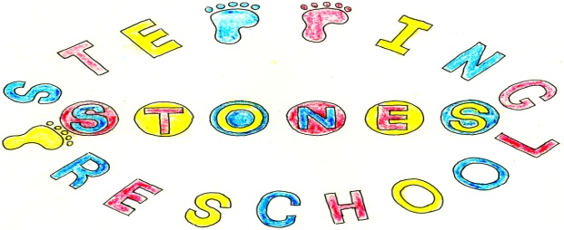

Stepping Stones Preschool Code of Conduct Policy

Parent’s and Carer’s code of Conduct
Stepping Stones Preschool is a caring and supporting preschool which aims to create a safe, happy and secure learning environment: Every Child, Every Chance, Every Day!
We are very fortunate to have very supportive, helpful and friendly parents, who recognise that educating children is a process that involves partnership between home and preschool. Our parents understand the importance of a good working relationship to ensure our children achieve their best. For this reason we welcome and encourage parents/carers to participate fully in the life of our preschool. The setting has a ‘parent, carer and visitor code of conduct’.
The purpose of this is to provide a reminder to all parents and visitors to our preschool about expected conduct so that we can work together to ensure a safe and positive preschool environment for our children.
Parents, Carers and Visitors will:
- Work together with staff for the benefit of the children
- Respect the caring ethos and values of our preschool
- Set a good example in their own speech and behaviour towards all members of the preschool community
- Approach our preschool in a calm and respectful manner to resolve any issues of concern or to discuss and clarify specific events in order to bring about a positive solution.
- Support and reinforce the preschool’s policy on behaviour
- Respect the learning environment appropriately (both in preschool and off site)
- Park with consideration and respect for others when delivering and collecting children from preschool and only in the school car park when there is identified need and a parking permit applied for from them.
- Use social media responsibility

Preschool will NOT tolerate Parents, Carers and Visitors:
Acting aggressively, using inappropriate language, displaying temper or acting in a threatening or intimidating manner towards staff, children or parents on the school premises or via social media or on the phone.
- Threatening harm or physical aggression towards a child, member of staff or parent
- Damaging or destroying school property
- Smoking and consuming alcohol or other drugs on our school site or accessing the school site whilst intoxicated or under the influence of drugs
- Social media, phones and emails being used to fuel complaints or concerns against our preschool, children staff or parents or being used for libellous or defamatory posts or cyber bullying.
- Parents not working with us for the best outcomes for their children.
We understand that sometimes parents/carers may wish to discuss sensitive issues of concern which we will be happy to do. If parents/carers have confidential things to discuss we will talk to you in the office away from other people. We will listen to your issues and seek solutions.
We have a duty to keep all staff members protected from abuse and threats. If parents/carers make threats and becomes angry or abusive we will ensure that two members of staff are present and record the incident. This record will be kept in the child’s records. Staff members will not take part in further conversation if a parent/carer becomes angry, abusive, intimidating, harasses us or makes threats. In cases where threats and abuse continue we will call the police and seek advice from Law Call. Thank you for abiding by this, together we can create, a positive and uplifting environment for the children and all who work here. Please sign that you acknowledge and will abide with this. If you ask any friends or relative to bring or collect your child from preschool please ensure they are also aware of this policy

THIS POLICY WAS ADOPTED AT A MEETING OF THE

PRESCHOOL HELD ON (DATE)...........................................................

SIGNED ON BEHALF OF THE PRESCHOOL.........................................

