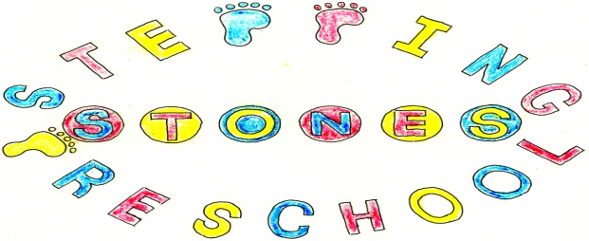

Stepping Stones Pre School

Transition and Continuity Policy

Our children predominantly transition to William Barnes Primary School and because of this our focus during our rising 5’s sessions is moving to this school.

For the autumn and spring term children attending any local primary school are welcome to attend our rising 5’s sessions. In the summer term our focus is heavily based on attending William Barnes so for those children attending a difference school attending this session could be detrimental to their smooth transition to their new school.

To School
Admission to our setting does not guarantee admission to any mainstream school.
We will welcome local reception teachers into the group and will pass out any information that they supply to parents.
We display schools information on our notice boards.
We work with schools to ensure smooth transition to new settings.
We will meet with the child’s parents, the school Senco and class teacher to ensure that children transfer to school with their needs understood and met, and ensure a smooth transition.
We will discuss children’s progress with parents before transition.
With parental permission we will pass transition forms and learning journeys to their new school.
We attend events and meetings so that we know what the schools expect for each child’s transition and can discuss with parents any worries or concerns that they may have.
We will talk about uniforms and going to school in the group to prepare the children for transition.
We will run a rising 5’s session to prepare children for the transition to school. These allow us to take children into the local school so that children get to know their teacher, teaching assistant and school routines and rules.
When children are not attending the local school we will welcome other reception teachers into pre school and encourage parents to attend their sessions preparing children for school.
To Other Pre Schools
We will provide up to date learning journey records for the parents to pass to their child’s new setting.

THIS POLICY WAS ADOPTED AT A MEETING OF THE
PRE-SCHOOL HELD ON (DATE)..........................................................

SIGNED ON BEHALF OF THE PRESCHOOL...........................................

