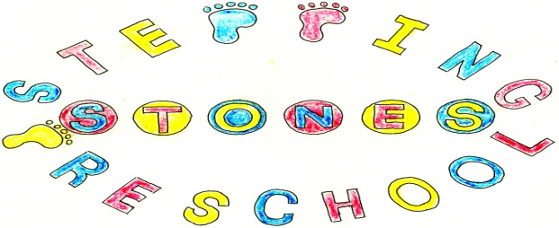

Stepping Stones Pre School
Behaviour Management Policy

We believe that children and adults flourish with a consistent routine in which everyone knows what is expected of them and when. We aim to work towards a situation in which children can regulate their own emotions and develop their self-esteem in an atmosphere of mutual respect and encouragement. In order to achieve this:-

Rules governing the conduct of the Group and the behaviour of the children will be discussed and agreed within the Pre School.

We will validate their emotions and feelings during behaviours of distress and work with them to co-regulate their emotions until such times as they can regulate their own emotions.

We create the setting rules with the children such as don’t hurt each other to promote acceptable behaviour and developing social skills.

A visual time line will be used to develop children’s understanding of the routine of the setting.

All adults in the Pre School will ensure that the rules are applied consistently, so that the children understand what is expected of them and can develop their agency and autonomy in a secure environment.

All adults will provide a positive role model for the children with regard to friendliness, care and courtesy.

Adults in the Pre School will praise and endorse appropriate behaviour such as kindness and willingness to share. Sharing will be supported by using a sand timer to ensure children learn to take turns fairly.

We will take positive steps to avoid a situation in which children receive adult attention only in return for undesirable behaviour.

When children behave in unacceptable ways:-

Physical punishment, such as smacking or shaking will not be used or threatened.

Techniques intended to single out and humiliate individual children such as the ‘naughty chair’ will not be used.

Children who exhibit behaviours of distress will be given adult support to validate their emotions and work together to co-regulate before trying to find a solution together to resolve the issue.

It is sometimes appropriate to move the child away from the situation causing the behaviours of distress.

Any direct or indirect racial, or prejudicial language or behaviour will be challenged. This would involve a discussion with the children parent or carer and a record of concern written if appropriate. The setting would work hard to challenge any prejudices through planning, resources and books.

In any case of behaviours of distress it will always be made clear to the child or children in question that it is the behaviour and not the child that is unwelcome.

Adults in the Pre School will make themselves aware of, and respect, a range of cultural expectations regarding interactions between people and be aware of both implicit and explicit prejudice.

Any inappropriate behaviours will be handled in a developmentally appropriate fashion, respecting individual children’s level of understanding and maturity.

Recurring problems will be tackled in partnership with the child’s parents or carers, using objective observation records such as an ABC chart to establish an understanding of the cause.

We will seek permission to work with other professionals to ensure that children are included in the setting wherever possible and make the best progress in their learning.

Adults will be aware that some behaviours may arise from the child’s needs and home experiences.

THIS POLICY WAS ADOPTED AT A MEETING OF THE
PRE SCHOOL HELD ON (DATE)...........................................................

SIGNED ON BEHALF OF THE PRE SCHOOL........................................

